# Updating and Creating Digital Object records using the Digital Object Manager

**Purpose:** Create new Digital Object records or update metadata on existing Digital Object records with the following fields:

* Title
* PID
* File URI
* Location (locally defined field)
* DO_Publish
* Restrictions
* FV_Publish
* Checksum
* Checksum Method

**Procedure:**

* Open digital_object_manager_template.csv
  + **Note:** when entering data DO NOT rearrange the columns – they must remain in this order for the DOM Update to work properly
* To create a new record: complete all fields on the spreadsheet. To update existing records: enter the metadata into the fields you wish to update, following the guidelines below:
  + **Note:** the Required/Optional column below refers to the DOM *Update* function.

|  |  |  |
| --- | --- | --- |
| **Field label** | **Use case** | **Required/Optional** |
| Title | Create/update the title of the digital object | Optional |
| PID | When updating digital objects with a user-defined Digital Object Identifier (ex. MS001.001.00001), use the Digital Object Identifier.  For digital objects with an ArchivesSpace assigned Digital Object Identifier (ex. 2e71e7bd-2959-4a0e-ae51-a7374d30ceca), use the Archival Object Component Unique identifier.  This will update the Digital Object Identifier to be “tufts:[AO CUI]” | Required |
| Handle | Create/update the File URI | Optional |
| Location | Create/update the location field for the digital object | Optional |
| DO_publish | TRUE/FALSE – controls whether or not to publish the Digital Object record | Optional |
| Restrictions | TRUE/FALSE  – indicates whether or not there are restrictions on the digital object | Optional |
| FV_publish | TRUE/FALSE - controls whether or not to publish the File Version section of the Digital Object record | Optional |
| Checksum | Creates/updates the checksum value of the digital object | Optional |
| Checksum method | Record the tool used to generate checksum values. Use only the values listed in the controlled value list for this field. | Optional, but required if recording a checksum value |

* Delete the top row containing headers
* If the top-left cell (A1) is blank, enter the following into the cell, to prevent it from collapsing and shifting values: =””
* Example of a completed csv, ready for upload, updating the restrictions field:

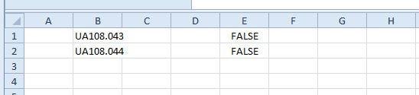

* Upload csv to the Digital Object Manager plug-in
  + To access the Digital Object Manager
    - Log into ASpace
    - Click on the gear icon to expand the menu and hover over Plug-ins. Select Digital Object Manager from the list. (See screenshot below).

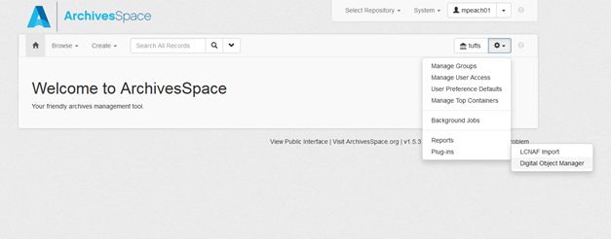

* Upload your csv to the Batch Update section

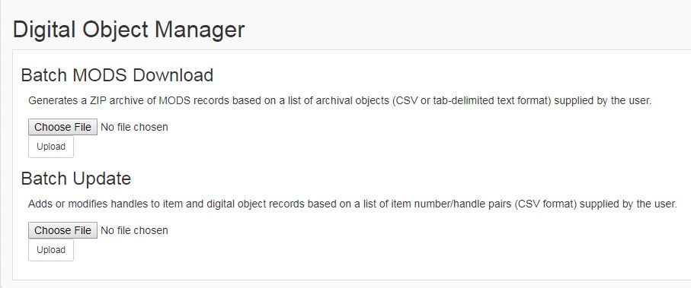

* Once upload is complete, an action log will be produced – open the text file and verify that all the digital objects were created or updated.
* QA some of the digital object records that you just created to ensure completeness and accuracy.